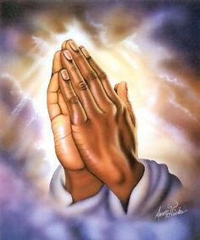



Year 3 Mass Dates:
Whole School Mass –
- Monday 8th September
- Monday 8th December- Immaculate Conception
Year 3 Mass –
- Wednesday 24th September
- Wednesday 22nd October
- Wednesday 26th November

Class Dojo:
Class dojo is the quickest and most up to date way of communicating with each other. Therefore, please check Class dojo regularly. Feel free to message with any queries and I will respond within 5 working days. If it is urgent, please contact the office.
Important Dates:
Roald Dahl Day – 12th September
Harvest Assembly – 3rd October
Black History Week: 20th October
Parliament Week: 3rd November
Anti-Bullying Week: 10th November
Odd Socks Day: 10th November
Remembrance Day: 11th November

PE/Swimming:
As part of keeping healthy and fit, for one week only, we have swimming, dates will be posted on Class Dojo.
P.E is on Thursday and Friday. Ensure that children have the correct swimming costumes and for P.E and appropriate footwear.

School Uniform:
Children should be wearing their winter uniform and school shoes.
Homework:
Children will be set homework regularly, which will be posted on Class dojo and/or Doodle. Please do not hesitate to contact me for passwords.


Dear parents,
Welcome back! I hope you all had a good summer holiday. Please read the class routines and expectations listed below. If you have any queries or questions, I will be happy to speak to you at the end of the day after all the children have been dismissed.
READING:
In Year 3, reading continues to be our priority. Children are expected to read daily for 15 -20 minutes and have their reading record checked and signed by parents every day!

